AAABG TRAVEL AWARD for WCGALP  (World Congress on Genetics Applied to Livestock Production) | 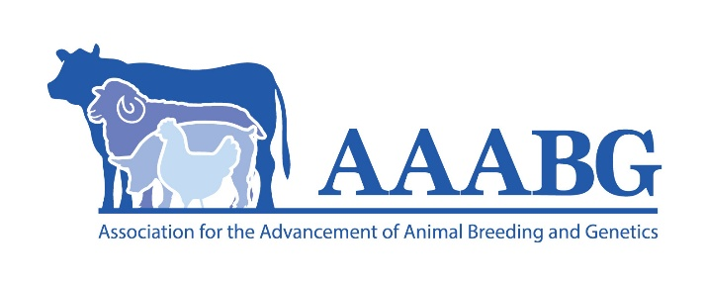
Application Form
1. Personal Details
Title: | (i.e. Dr, Mr, Mrs, Ms, Miss) |  | Family name: |  |  |  |  |  |  |  |  |  | Given name(s):
Date of Birth: |  |  |  |  | / |  |  |  | / |  |  |  | Gender |  | Male: |  |  |  | Female:
 |  |  | (Day/Month/Year) |  |  |  |  |  |  |  |  |  |  | Prefer not to disclose: |  |  |  |  | Other:
 |  |  |  |  |  |  |  |  |  |  |  |  | (Please tick appropriate box)
Current Mailing Address:
State: |  |  |  |  |  | Postcode: |  |  |  |  |  |  |  |  |  | Country:
Email:
Telephone: |  |  |  |  |  |  |  |  |  |  | Mobile:

2. Details of course
Please indicate your degree:
1 | Post-graduate (PhD or MSc) in Animal Genetics or related subject |  | PhD |  |  | MSc
2 | Australian University |  | Yes |  |  | No
3 | New Zealand University |  | Yes |  |  | No
(Please tick appropriate boxes)
Please provide a brief biography including description of your university, thesis or course, supervisors and motivation for attending WCGALP (less than 500 words)
Please provide a detailed itinerary for the proposed travel:
Date of travel |  | Activity details  (i.e. flights, conference attendance, additional visits) |  | Location
A supplementary attachment may be included if more space is required. Please attach any supporting documentation (i.e. acceptance of conference paper/poster/abstract, workshop or course registration information, research exchange/study tour letter/s of invitation).
3. Benefit Statement
Please provide your submitted WCGALP title and abstract (one paper only).
Also provide a brief rationale for the relevance of the research to the WCGALP audience.
Title:

Relevance of study to WCGALP audience:

Abstract:

4. Budget Estimate Statement
Other Funding and Scholarships
Are you currently in receipt of any Scholarships (Studies and/or Travel)? |  |  | Yes: |  | No:
(Please tick appropriate box)
If yes, provide details below:
Scholarship(s) held:
With respect to your proposed travel to the WCGALP using the AAABG Travel Grant, have you applied
for, received or do you expect to receive funding from another source? |  |  | Yes: |  | No:
(Please tick appropriate box)
Please provide a brief budget below in Australian Dollars of the estimated expenses for the WCGALP travel, inclusive of any funding already received or expected (note the source of any additional funding)
 | Description (e.g. airfares, accommodation, conference registration fees etc.) |  |  |  | Amount (Approx. in AU$)
1 |  |  |  |  | $
2 |  |  |  |  | $
3 |  |  |  |  | $
4 |  |  |  |  | $
5 |  |  |  |  | $
6 |  |  |  |  | $
7 |  |  |  |  | $
8 |  |  |  |  | $
9 |  |  |  |  | $
10 |  |  |  |  | $
 | Total cost of travel |  |  |  | $
 | Funds from other sources (please specify) |  |  |  | $
 | Funds requested from AAABG |  |  |  | $
A supplementary attachment may be included if more space is required.

5. Academic Qualifications
Please list all tertiary level studies:
Degree or Qualification | University or Institution | Date Completed

6. Professional Experience
Please detail any relevant professional employment experience in an Animal Genetics related field:
Name of employer | Your duties/position | Dates

7. Declaration
- I certify that I have read and understood the questions on this form, and the associated AAABG Travel Award for WCGALP terms and conditions, and that the answers provided on this form are true and correct.
- I certify that I have submitted the abstract as included in this document to WCGALP.
- I understand that giving false or misleading information is a serious offence under the Criminal Code (Australian Commonwealth).
- I understand that the AAABG may vary or cancel any decision made based on incorrect or incomplete information provided by me.
- I acknowledge that AAABG may use some information from this application for publicity purposes.
- I agree to abide by the AAABG Conditions of Award which may be amended from time to time by the Association.

Please sign and date this declaration before emailing.

Your application will not be processed if it has not been signed below.

Signed: |  | Date: |  | / |  | /

8. Submitting the Application Form and Supporting Documentation
Please ensure that you complete all sections of the Application Form as per the instructions and provide all supporting documentation as requested in the terms and conditions and guidelines together with the Application form as a single pdf document.

You must sign the declaration before emailing your completed application to the AAABG Executive Officer (sue@makinoutcomes.com.au).

AAABG Travel Award for WCGALP enquiries should be directed to:
Dr Sue Hatcher, AAABG Executive Officer
M: 0407 006 454
E: sue@makinoutcomes.com.au

